**Advantages of studying Deep Learning**

Deep learning is a buzz-word, synonymous with cutting edge Artificial Intelligence. Whether it’s Waymo’s self driving car, OpenAI’s DoTA playing AI or digital smart assistants like Siri or Alexa, the impact that deep learning has had on modern day technology is significant.

Let us discuss some of the advantages studying deep learning.

1. **Data-Driven Everything:** You might have heard about how data is king in Deep Learning Systems. Another way to look at it is that Deep Learning can be applied to ANY domain at some capacity, so long as there are volumes of data generated to train the models. From Domains such as healthcare, to athletics, to geoinformatics all the way to gaming, fashion and virtual-reality. Deep Learning will work, provided there is data to train models on.
2. **Highly Accessible:** If you’ve stumbled across advertisements for deep-learning courses, softwares, frameworks etc, it is a direct reflection of how accessible the technology has become to the public. Advancements in software, hardware and the open-source community of Deep Learning Practitioners have made DL the most accessible it’s ever been since its inception. With no shortage of comprehensive coursework and tutorials, highly user-friendly frameworks and complete Democratization of models and data, the deep-learning era is truly upon us.
3. **Math and Python:** As this point is titled, high-school math and basic knowledge of Python syntax is all you need to begin your journey as a deep learning practitioner. The beauty of the field is that one can choose to spend hours and weeks understanding the underlying mathematical concepts behind DL, or simply move onto the practical implementation and have it finished in 10-15 lines of code. Modern day deep learning frameworks are powerful, yet designed with the aim of moving from ideation to production in the shortest amount of time, ie highly intuitive and excellent at abstracting the core workings behind a few simple lines of code. Doctors, Lawyers, Physiotherapists, Musicians etc around the world have been able to make use of Deep Learning to supplement their profession. The field is not restricted to PhD holders and expert software developers.
4. **0 to 60 in 0.5**: With no dearth of excellent tutorials (like our PadhAI Deep Learning Series), one can expect to go from being a complete beginner to having implemented complex models capable of tasks such as Object Detection, Character Recognition, Translation etc in as little as half a year. With around 5-8 hours of study per week and around 6 months of time, learners can progress rapidly from novice to intermediate/adept levels.

**Deep Learning Career Opportunities**

The following infographic will help you understand the skill requirements for different job opportunities in the Deep Learning field.

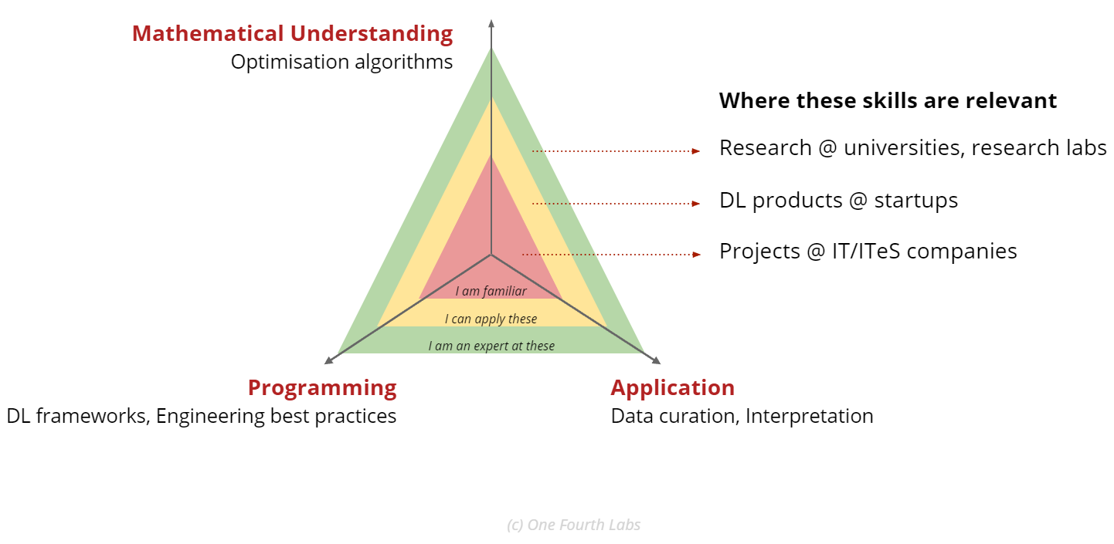

We can see that there are broadly 3 levels of competence in Deep Learning, which will open doors to new career opportunities.

**Projects @ IT/ITeS Companies:** For those looking to transition into DL/ML projects at IT companies, familiarity of programming, application and mathematics behind deep learning will be suitable.

**DL products @ startups:** For those looking to join startups focused on DL products, a working level of proficiency in programming, mathematics and application of DL techniques would be required

**Research @ universities, research labs:** For those looking to enter the research field, expert understanding of Deep-Learning, its underlying concepts and its practical application are required.